**Morse Code**

Morse Code is a method of telecommunication, used to transmit messages to longer distances across telegraph wires via electric pulses represented as short pulse(dot) and long pulse(dash). In the beginning of 19th century the messages were delivered either with horses or with ravens. For the first time in the history of mankind a group of scientists invented a telecommunication device called telegraph, which was used to transmit the electric pulses to the other device. They developed an electronic device which could send the electric pulses to longer distances within less time. Then, Samuel F.B Morse invented a communication language which can be used with the electric pulse signals for the communication. These electronic pulses can be represented as long pulse(dash) and short pulse(dot). One short pulse and one long pulse can be represented as A and one long pulse, three short pulses can be represented as B. In this way they have successfully invented a communication language which can be associated with electronic pulses to transmit messages to distinct places.

The morse code consists a total of 36 characters out of which 26 characters are alphabets and remaining 10 characters are digits. There is no variation between lowercase and uppercase letters. Each morse code symbol is formed by a sequence of dots and dashes. If we consider the duration of dot as one unit then the duration of dash will be considered as three units. In the basic morse code transmission the letters present in the word are separated by a space which is having a duration of three dots, and the words are separated by a space equal to seven dots.

|  |  |  |  |
| --- | --- | --- | --- |
| **English Text** | **Morse Code** | **English Text** | **Morse Code** |
| A |  | S |  |
| B |  | T |  |
| C |  | U |  |
| D |  | V |  |
| E |  | W |  |
| F |  | X |  |
| G |  | Y |  |
| H |  | Z |  |
| I |  | 0 |  |
| J |  | 1 |  |
| K |  | 2 |  |
| L |  | 3 |  |
| M |  | 4 |  |
| N |  | 5 |  |
| O |  | 6 |  |
| P |  | 7 |  |
| Q |  | 8 |  |
| R |  | 9 |  |

Morse Code allowed ships at sea to communicate over long distances using large lights. This was especially pivotal during the second World War because it greatly improved the speed of communication. Naval warships were able to communicate with their bases and provide critical information to each other. Warplanes also used morse code to detail locations for enemy ships, bases, and troops and relay them back to headquarters. The International Morse Code is still used by the US Navy intelligence specialists, amateur radio operator afficionados who form the morse code preservation society, and aviators who communicate abbreviated identifiers via morse code. Morse Code has also been used as an alternative form of communication for people with disabilities or who have their abilities to communicate impaired by stroke, heart attack, or paralysis. There have been several cases where individuals have been able to use their eyelids to communicate in Morse Code by using a series of long and quick blinks to represent the dots and dashes.

**Lenet**

Lenet is a convolutional neural network structure proposed by LeCun in 1998. LeNet-5 was one of the earliest convolutional neural network which advanced the development of Deep Learning. As this is the basic convolutional neural network, it contains the convolutional layers, pooling layers, flatten layer and fully connected layers. The convolutional layer is used to extract the important features present in the input image. The pooling layers are used to reduce the dimensions of the feature map, and the max pool is used to get the maximum value of the feature map. The flatten layer is used to convert all the 2D arrays from pooled feature maps into a single long continuous linear vector. The fully connected layer is used the image classification. This architecture was mainly used for recognizing the handwritten images and machine-printed characters. This Lenet contains 5 layers with learnable parameters hence it was named as Lenet-5. This architecture contains three sets of convolutional layers and average pooling layers, and two fully connected layers. At the last layer, a Softmax classifier which classifies the images into respective classes.

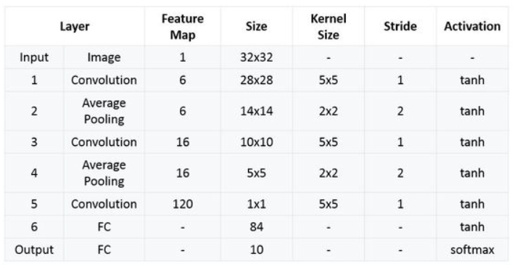

The first layer is the input layer with the input size as 32X32X1, followed by the first convolutional layer with 6 filters of size 5X5 and a stride 1. To calculate output size of Convolutional layer formula is : “output = ((input – filter size) / stride ) +1”. The activation function used in the first layer is tanh. The output of the feature map is 28X28X6. Next, an average pooling layer with filter size 2X2 and stride 1. The output of this layer is 14X14X6 feature map. Later, the second convolutional layer with 16 filters of 5X5 and stride 1, the activation function is tanh but the output size is 10X10X16. Next, another average pooling layer of 2X2 with stride 2, then the size of the output feature map is 5X5X6. Then the final pooling layer, which has 120 filters of 5X5 with stride 1 and activation function as tanh, now the output we obtained is 120. Next, the fully connected layer with 84 neurons, which results in the output to 84 values with the same activation function tanh. Finally, the last layer contains 10 neurons with activation function as Softmax, which classifies the images based on the training. Hence the highest value is predicted. The total number of trainable parameters are sixty thousand.

**AlexNet**

AlexNet is the most popular neural network in the Pre-trained model of computer vision domain. This model was proposed in 2012 in the research paper named Image Classification with Deep Convolutional Neural Network by Alex Krizhevsky and his colleagues. The AlexNet has a total of eight layers with learnable parameters. This consists of five layers with a combination of max pooling layer followed by 3 fully connected layers. Except the ouput layer all the layers has the Relu activation function, as the Relu activation function does not activate all the neurons, accelerate the training process by six times and it is used to avoid the vanishing gradient problem. This architecture also consists of dropout layers which prevent the model from overfitting and the batch normalization layer which is used to decrease the epochs and increase the speed and performance of neural networks.

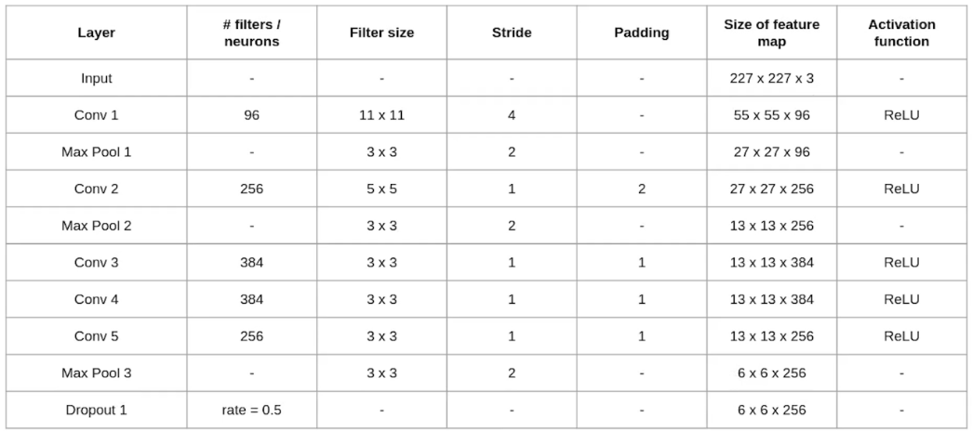

The first layer is the input layer with the input image size as 227X227X3, followed by the first convolutional layer with 96 filters of size 11X11 with stride 4 and the activation function is Relu. The output of this layer is 55X55X96. Next, we have the first max pooling layer of size 3X3 and stride 2. The output of this layer is 27X27X96. After this, the second convolutional layer is applied with filter size 5X5 and have 256 such filters, with stride 1 and padding 2, activation function is Relu. Here the size of output layer is 27X27X256. Then, max pooling layer of size 3X3 with stride 2. Then the output feature map is of size 13X13X256. Then, the third convolutional operation with 384 filters of size 3X3 ,stride 1 and padding 1. The output size of this layer is 13X13X384. Next, the final convolutional layer of size 3X3 with 256 such filters. The output of this layer is 13X13X256. Next, we apply the third max-pooling layer of size 3X3 and stride 2. The output of the feature map is 6X6X256. Then, the first fully connected layer with Relu activation function. The size of the output is 4096, followed by a dropout layer with dropout rate fixed at 0.5. Followed by a second fully connected layer with 4096 neurons and Relu activation function. Finally, the last fully connected layer with the softmax activation function.